Software Design
for

Campus Management Application
at
World Skill Center (WSC)

Design Feature - Students Management Module



Sustainable Outreach And Universal Leadership (SOUL) Limited
Version no 0.1
VERSION HISTORY
Date | Version No. | Created By | Updated Section | Updated By
26-03-2023 | Version 0.1 | Nehal Kumar

Contents
1. Introduction 10
2. LITERATURE REVIEW 10
3. Platform Overview 11
3.1 Platform requirements 11
3.1.1 Software Stack 11
3.2.2 Hosting requirement 11
4. Architecture 11
5. Organization Structure: 12
6. Design Overview: 13
6.1 Hostel Masters 13
6.1.1 Overview 13
6.1.2 Description of Problem 13
6.1.3 A Table of Contents 13
6.1.4 Use Case 13
6.1.5 Form Elaboration 13
6.1.6 Screen Authorization 14
6.1.7 Component And Module 14
6.1.8 Business Logic 14
6.1.9 Path of the screen 14
6.2 Room Masters 14
6.2.1 Overview 15
6.2.2 Description of Problem 15
6.2.3 Dependency 15
6.2.4 A Table of Contents 15
6.2.5 Use Case 15
6.2.6 Form Elaboration 15
6.2.7 Component And Module 16
6.2.8 Screen Authorization 16
6.2.9 Business Logic 16
6.2.10 Path of the screen 16
6.3 Hostel Type 16
6.3.1 Overview 16
6.3.2 Description of Problem 16
6.3.3 Dependency 16
6.3.4 Table of Contents 17
6.3.5 Use Case 17
6.3.6 Form Elaboration 17
6.3.7 Screen Authorization 17
6.3.8 Component And Module 17
6.3.9 Business Logic 17
6.3.10 Path of the screen 18
6.4 Room Type 18
6.4.1 Overview 18
6.4.2 Description of Problem 18
6.4.3 Table of Contents 18
6.4.4 Use Case 18
6.4.5 Form Elaboration 18
6.4.6 Screen Authorization 19
6.4.7 Component And Module 19
6.4.9 Business Logic 19
6.4.10 Path of the screen 19
6.5 Room Description 19
6.5.1 Overview 19
6.5.2 Description of Problem 19
6.5.3 Dependency 19
6.5.4 Table of Contents 19
6.5.5 Use Case 19
6.5.6 Form Elaboration 20
6.5.7 Screen Authorization 20
6.5.8 Component And Module 20
6.5.9 Business Logic 20
6.5.10 Path of the screen 21
6.6 Employee Hostel Allotment 21
6.6.1 Overview 21
6.6.2 Description of Problem 21
6.6.3 Dependency 21
6.6.4 Table of Contents 21
6.6.5 Form Elaboration 21
6.6.6 Use Case 21
6.6.7 Component And Module 22
6.6.8 Screen Authorization 22
6.6.9 Business Logic 22
6.6.10 Path of the screen 22
6.7 Student Hostel Admission 22
6.7.1 Overview 22
6.7.2 Description of Problem 23
6.7.3 Dependency 23
6.7.4 Flow Chart 23
6.7.5 Table of Contents 23
6.7.6 Use Case 23
6.7.7 Form Elaboration 24
6.7.8 Screen Authorization 24
6.7.9 Component And Module 25
6.7.10 Business Logic 25
6.7.11 Path of the screen 25
6.8 Student Medical History 25
6.8.1 Overview 25
6.8.2 Description of Problem 25
6.8.3 Dependency 25
6.8.4 Flow Charts 25
6.8.5 Table of Contents 26
6.8.6 Use Case 26
6.8.7 Form Elaboration 26
6.8.8 Screen Authorization 28
6.8.9 Component And Module 28
6.8.10 Business Logic 28
6.8.11 Path of the screen 28
6.9 Student Leave Process 28
6.9.1 Overview 28
6.9.2 Description of Problem 28
6.9.3 Dependency 28
6.9.4 Flow Charts 29
6.9.5 Table of Contents 29
6.9.6 Use Case Diagram 29
6.9.7 Form Elaboration 29
6.9.8 Screen Authorization 30
6.9.9 Component And Module 30
6.9.10 Business Logic 30
6.9.11 Path of the screen 30
6.10 Material Distribution 30
6.10.1 Overview 30
6.10.2 Description of Problem 31
6.10.3 Dependency 31
6.10.4 Flow Charts 31
6.10.5 A Table of Contents 31
6.10.6 Use Case Diagram 31
6.10.7 Form Elaboration 32
6.10.8 Screen Authorization 33
6.10.9 Component And Module 33
6.10.10 Business Logic 33
6.10.11 Path of the screen 33
6.11 Room Allotment 33
6.11.1 Overview 33
6.11.2 Description of Problem 33
6.11.3 Dependency 33
6.11.4 Flow Charts 34
6.11.5 A Table of Contents 34
6.11.6 Use Case Diagram 34
6.11.7 Form Elaboration 34
6.11.8 Screen Authorization 35
6.11.9 Component And Module 36
6.11.10 Business Logic 36
6.11.11 Path of the screen 36
6.12. Room De-Allotment 36
6.12.1 Overview 36
6.12.2 Description of Problem 36
6.12.3 Dependency 36
6.12.4 Flow Charts 36
6.12.5 Table of Contents 36
6.12.6 Use Case Diagram 37
6.12.7 Form Elaboration 37
6.12.8 Screen Authorization 38
6.12.9 Component And Module 38
6.12.10 Business Logic 38
6.12.11 Path of the screen 38
6.13. Room Change 38
6.13.1 Overview 38
6.13.2 Description of Problem 38
6.13.3 Dependency 38
6.13.4 Flow Charts 39
6.13.5 Table of Contents 39
6.13.6 Use Case Diagram 39
6.13.7 Form Elaboration 39
6.13.8 Screen Authorization 40
6.13.9 Component And Module 40
6.13.10 Business Logic 40
6.13.11 Path of the screen 40
6.14. Death De-Allotment 40
6.14.1 Overview 40
6.14.2 Description of Problem 41
6.14.3 Dependency 41
6.14.4 Flow Charts 41
6.14.5 Table of Contents 41
6.14.6 Use Case Diagram 41
6.14.7 Form Elaboration 42
6.14.8 Screen Authorization 42
6.14.9 Component And Module 43
6.14.10 Business Logic 43
6.14.11 Path of the screen 43
6.15. Long Leave 43
6.15.1 Overview 43
6.15.2 Description of Problem 43
6.15.3 Dependency 43
6.15.4 Flow Charts 44
6.15.5 A Table of Contents 44
6.15.6 Use Case Diagram 44
6.15.7 Form Elaboration 44
6.15.8 Screen Authorization 45
6.15.9 Component And Module 45
6.15.10 Business Logic 45
6.15.11 Path of the screen 46
6.16 Inter or Intra Hostel Change 46
6.16.1 Overview 46
6.16.2 Description of Problem 46
6.16.3 Dependency 46
6.16.4 Flow Charts 46
6.16.5 A Table of Contents 46
6.16.6 Use Case Diagram 46
6.16.7 Form Elaboration 47
6.16.8 Screen Authorization 47
6.16.9 Component And Module 48
6.16.10 Business Logic 48
6.16.11 Path of the screen 48
6.17 Hostel Fee Structure 48
6.17.1 Overview 48
6.17.2 Description of Problem 48
6.17.3 Dependency 48
6.17.4 Table of Contents 48
6.17.5 Use Case Diagram 49
6.17.6 Form Elaboration 49
6.17.7 Screen Authorization 49
6.17.8 Component And Module 50
6.17.9 Business Logic 50
6.17.10 Path of the screen 50
6.18 Hostel Fee Schedule 50
6.18.1 Overview 50
6.18.2 Description of Problem 50
6.18.3 Dependency 50
6.16.4 Flow Charts 51
6.18.5 Table of Contents 51
6.18.6 Use Case Diagram 51
6.18.7 Form Elaboration 52
6.18.8 Screen Authorization 52
6.18.9 Component And Module 52
6.18.10 Business Logic 52
6.18.11 Path of the screen 53
6.19 Hostel Fees 53
6.19.1 Overview 53
6.19.2 Description of Problem 53
6.19.3 Dependency 53
6.19.4 Flow Charts 53
6.19.5 A Table of Contents 54
6.19.6 Use Case Diagram 54
6.19.7 Form Elaboration 55
6.19.8 Screen Authorization 55
6.19.9 Component And Module 56
6.19.10 Business Logic 56
6.19.11 Path of the screen 56
6.20 Indisciplinary Complaint Registration 56
6.20.1 Overview 56
6.20.2 Description of Problem 57
6.20.3 Dependency 57
6.20.4 Flow Charts 57
6.20.5 A Table of Contents 57
6.20.6 Use Case Diagram 57
6.20.7 Form Elaboration 58
6.20.8 Screen Authorization 58
6.20.9 Component And Module 58
6.20.10 Business Logic 59
6.20.11 Path of the screen 59
6.21 Indisciplinary Actions 59
6.21.1 Overview 59
6.21.2 Description of Problem 59
6.21.3 Dependency 59
6.21.4 Flow Charts 59
6.21.5 Use Case Diagram 60
6.21.6 Table of Contents 60
6.21.7 Form Elaboration 61
6.21.8 Screen Authorization 61
6.21.9 Components And Modules 62
6.21.10 Business Logic 62
6.21.11 Path of the screen 62
6.22 Disciplinary Committee Meeting 62
6.22.1 Overview 62
6.22.2 Description of Problem 62
6.22.3 Dependency 62
6.22.4 Flow Charts 62
6.22.5 Use Case Diagram 63
6.22.7 Form Elaboration 64
6.22.8 Screen Authorization 64
6.22.9 Components And Modules 64
6.22.10 Business Logic 65
6.22.11 Path of the screen 65
6.23 Withdrawal of Suspension 65
6.23.1 Overview 65
6.23.2 Description of Problem 65
6.23.3 Dependency 65
6.23.4 Flow Charts 65
6.23.5 Use Case Diagram 66
6.23.7 Form Elaboration 67
6.23.8 Screen Authorization 67
6.23.9 Components And Modules 67
6.23.10 Business Logic 67
6.23.11 Path of the screen 67
6.24 Hostel Suspension Room Change 68
6.24.1 Overview 68
6.24.2 Description of Problem 68
6.24.3 Dependency 68
6.24.4 Flow Charts 68
6.24.5 Use Case Diagram 68
6.21.6 Table of Contents 69
6.24.7 Form Elaboration 69
6.24.8 Screen Authorization 70
6.24.9 Components And Modules 70
6.24.10 Business Logic 70
6.24.11 Path of the screen 70
6.25 Inward Suspension Letter 70
6.25.1 Overview 70
6.25.2 Description of Problem 70
6.25.3 Dependency 70
6.25.4 Flow Charts 71
6.25.5 Use Case Diagram 71
6.21.6 Table of Contents 71
6.25.7 Form Elaboration 72
6.25.8 Screen Authorization 72
6.25.9 Components And Modules 72
6.25.10 Business Logic 72
6.25.11 Path of the screen 72
6.26 Withdrawal of Inward Suspension Letter 72
6.26.1 Overview 72
6.26.2 Description of Problem 73
6.26.3 Dependency 73
6.26.4 Flow Charts 73
6.26.5 Use Case Diagram 73
6.26.7 Form Elaboration 74
6.26.8 Screen Authorization 74
6.26.9 Components And Modules 75
6.26.10 Business Logic 75
6.26.11 Path of the screen 75
6.27 Hostel Attendance 75
6.27.1 Overview 75
6.27.2 Description of Problem 75
6.27.3 Dependency 75
6.27.4 Flow Charts 75
6.27.5 Use Case Diagram 76
6.27.7 Form Elaboration 76
6.27.8 Screen Authorization 77
6.27.9 Components And Modules 77
6.27.10 Business Logic 77
6.27.11 Path of the screen 77
6.28 Hostel Attendance Tool 77
6.28.1 Overview 77
6.28.2 Description of Problem 77
6.28.3 Dependency 78
6.28.4 Flow Charts 78
6.28.5 Use Case Diagram 78
6.28.6 Table of Contents 78
6.28.7 Form Elaboration 78
6.28.8 Screen Authorization 78
6.28.9 Components And Modules 79
6.28.10 Business Logic 79
6.28.11 Path of the screen 79
6.29 Hostel Clearance 79
6.29.1 Overview 79
6.29.2 Description of Problem 79
6.29.3 Dependency 79
6.29.4 Flow Charts 79
6.29.5 Use Case Diagram 80
6.29.6 Table of Contents 80
6.29.7 Form Elaboration 80
6.29.8 Screen Authorization 81
6.29.9 Components And Modules 81
6.29.10 Business Logic 81
6.29.11 Path of the screen 81

- Introduction

Campus management project for WSC aims at providing an efficient, secure, and user-friendly platform to manage and automate the various processes. It is an integrated system that provides all the necessary tools to manage the various aspects of running a University. This web-based solution enables administrators and faculty to easily track and manage activities related to student registration and enrollment, faculty and staff management, financial management, facility management, and more. Additionally, it also provides features such as reporting and analytics, notification to students and parents using emails.
Scope of project:
- Students Management Modules
- Academic System
- Procurement & Inventory Management
- Human Resources Management System
- Finance and Accounting System
- Training and Placement
- Infrastructure

- LITERATURE REVIEW
The following section first explains the evolution of ERP system and some of its characteristics. It also explores the various modules available in an ERP software. Knowledge-intensive nature of ERP systems and ERP system adoption is also analyzed. Finally it looks into critical success factors for ERP system implementation as well as benefits of ERP implementation.

- Platform Overview

3.1 Platform requirements

3.1.1 Software Stack
Our application use Frappe framework as the major software stack which is an open-source full stack web framework written in Python and JavaScript that is used to develop and maintain web applications. It is designed to be simple, easy to use, and fast. It is built on top of the popular Django web framework. Frappe provides a powerful set of tools for building web applications with a focus on scalability and extensibility. It provides a powerful ORM, a powerful templating system, and a comprehensive set of APIs for building web applications. Frappe is also designed for ease of use, with a focus on reducing development time and building an intuitive admin interface. It also features a seamless integration with other open-source projects such as Redis, MongoDB, and MySQL, as well as a host of APIs and other tools.

3.2.2 Hosting requirement
Our application requires a Linux-based hosting environment. It requires at least 1GB of RAM, 2GB of disk space, and preferably an Ubuntu 16.04 or higher operating system. It also requires a web server such as Apache or Nginx, MariaDB 10.1 or higher, and Python 2.7.x or higher. Additionally, it requires an SMTP server to send emails and an SSL certificate to enable HTTPS.

- Architecture
Our application is based on a web-based, modular, service-oriented architecture (SOA), which allows for the development of custom applications and services that can be integrated with the core Our application platform. It is built on a combination of JavaScript, Python, and MySQL. The architecture of Our application consists of multiple layers, each with its own set of functions and services. At the highest level are the user interface, user experience, and application logic components. These components provide the user with an interface to the Our application system and the ability to interact with the underlying data and services. Below the user interface layer is the data layer, which is responsible for managing the storage and retrieval of data and services. This layer is powered by a combination of MySQL and PostgreSQL databases. The data layer is also responsible for providing secure access to the data and services. The application layer is responsible for providing access to the data and services, as well as providing the business logic that drives the system. The application layer is powered by a combination of Python and JavaScript, and is responsible for providing the core capabilities of the system, such as authentication, authorization, reporting, and analytics. Finally, the service layer is the layer that connects the application layer to the user interface layer. It provides the ability to integrate the Our application system with external systems and services, such as third-party APIs and web services. The service layer is powered by a combination of web services and web sockets. Following is a diagram showing a representation of the architecture of our application:

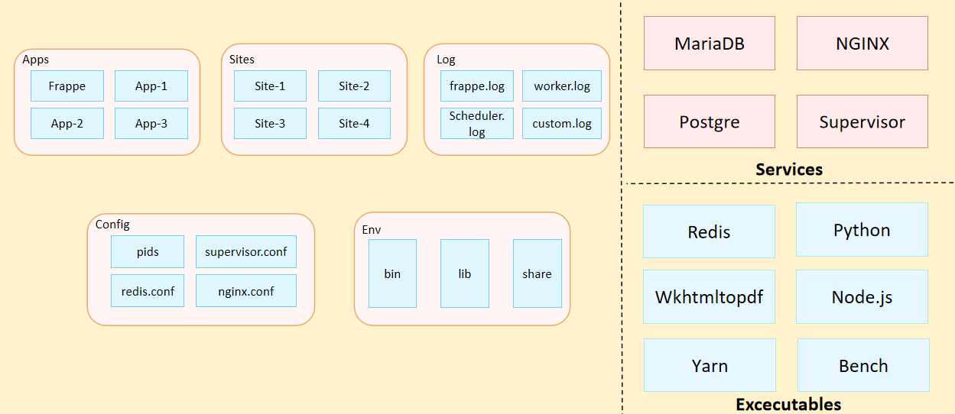
Fig: Architecture of Our Application

- Organization Structure:
Input required form WSC

- Design Overview:

6.1 Hostel Masters
    - Overview
The Hostel Master typically displays information related to the hostel's rooms, hostel’s type, occupants, address, and other related data, and through that master screen all action will going to be charge.
    - Description of Problem
Create a page containing all Information about Hostel type in the system.
    - A Table of Contents
- Main Table:- TabHostel Masters
    - Use Case

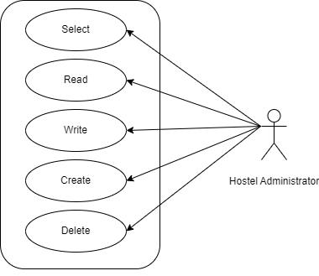

    - Form Elaboration
SL No | Label | Type | Mandatory
1 | Hostel Name | Data | 1
2 | Hostel Short Name | Data | 1
3 | Hostel Phone Number 1 | Data | 1
4 | Hostel Phone Number 2 | Data
5 | Hostel Type | Link | 1
6 | Total Floors | Int | 1
7 | Total Rooms | Int | 1
8 | Campus | Data
9 | No. Of Blocks | Int
10 | Start Date | Date | 1
11 | End Date | Date | 1
12 | Address Line 1 | Data
13 | Address Line 2 | Data
14 | Pincode | Data
15 | City | Data
16 | State | Data

    - Screen Authorization
Sl No. | Role | Level | Select | Read | Write | Create | Delete | Submit
1 | Hostel Administrator | 0 | 1 | 1 | 1 | 1 | 1 | 0

    - Component And Module
Module Related:- Education

    - Business Logic
- Go to the Hostel Masters list, click on New.
- Enter Hostel Name, Hostel Short Name, Hostel Phone Number, Hostel Type, Total Floors, Total Rooms, Date, Address etc.
- Click on save.
    - Path of the screen
Home > Hostel > Master > Hostel Masters

  - Room Masters
    - Overview
The Room Masters screen show the details of rooms for particular hostel.
    - Description of Problem
Create a page containing all Information about hostel and room information.
    - Dependency
Before creating a Room Master, it is advisable you to create the following documents:
- Hostel Master
- Room Type
    - A Table of Contents
- Main Table- TabRoom Masters
    - Use Case
    - Form Elaboration
SL No | Fields | Data Type | Mandatory
1 | Hostel | Link | 1
2 | Floor Number | Select | 1
3 | Validity | Select | 1
4 | Room Number | Data | 1
5 | Room Description | Link | 1
6 | Block | Data | 1
7 | Default Room Type | Link | 1
8 | Default Room Capacity | Select | 1
9 | Default Room Type Feature | Data
10 | Default Room Description | Data
11 | Current Room Type | Link | 1
12 | Current Room Capacity | Select | 1
13 | Vacancy | Data
14 | Room Type Feature | Data
15 | Description | Data

    - Component And Module
Module Related:- Education.
    - Screen Authorization
Sl No. | Role | Level | Select | Read | Write | Create | Delete | Submit
1 | Hostel Administrator | 0 | 1 | 1 | 1 | 1 | 1 | 0

    - Business Logic
- Go to the Room Masters list, click on New.
- Select Hostel,Floor Number, Validity,Default Room Type,Current Room Type, Current Room Capacity.
- Enter Room Number, Room Description,Block.
- Click on Save.

    - Path of the screen
Home > Hostel > Master > Room Masters
  - Hostel Type
    - Overview
Hostel Type is a master screen where you can define type of hostel.
    - Description of Problem
In this screen user can define Hostel type. It can be for boys and girls.
    - Dependency
No Dependency
    - Table of Contents
- Main Table- TabHostel Type
    - Use Case
    - Form Elaboration
Sl No | Field Name | Type | Mandatory
1 | Hostel Type | Data | 1

    - Screen Authorization
Sl No. | Role | Level | Select | Read | Write | Create | Delete | Submit
1 | Hostel Administrator | 0 | 1 | 1 | 1 | 1 | 1 | 0

    - Component And Module
Module Related:- Education

6.3.9 Business Logic

- Go to the Hostel Type and click on New.
- Enter the Hostel Type Name.
- Click on Save

6.3.10 Path of the screen
Home > Hostel > Master > Hostel Type
  - Room Type
    - Overview
Room Type is a master screen where you can define the type of Room.
    - Description of Problem
In this screen user can define Room type. It can be Ac and Non-Ac. Also you can mention Feature like Premium, Non-Premium and Super-Premium.

    - Table of Contents
- Main Table- TabRoom Type

    - Use Case

    - Form Elaboration
Sl No. | Field name | Mandatory | Type
1 | Criteria Name | 1 | Data

    - Screen Authorization
Sl No. | Role | Level | Select | Read | Write | Create | Delete | Submit
1 | Hostel Administrator | 0 | 1 | 1 | 1 | 1 | 1 | 0

    - Component And Module
Module: - Education Module

6.4.9 Business Logic
- Go to Room Type List and click on New.
- Enter the Room Type, Description.
- Auto fetch Start Date and End Date but you can only change End Date.
- Select Capacity, Type of Room and Feature
- Click on Save.

6.4.10 Path of the screen
Home > Hostel > Master > Room Type
  - Room Description
    - Overview
The Room Description allow you to give full description about the room.
    - Description of Problem
Create a page containing all Information about a description of the room and Status of the room.

    - Dependency
No Dependency
    - Table of Contents
- Main Table:- TabRoom Description
    - Use Case
    - Form Elaboration
Sl No | Field Name | Type | Mandatory
1 | Room Description | Data | 1
2 | Status | Select | 1
3 | Start Date | Date | 1
4 | End Date | Date | 1

    - Screen Authorization
Sl No. | Role | Level | Select | Read | Write | Create | Delete | Submit
1 | Hostel Administrator | 0 | 1 | 1 | 1 | 1 | 1 | 0

    - Component And Module
Module: - Education Module

6.5.9 Business Logic
- Go to Room Description and click on New.
- Enter the Room Description.
- Auto fetch Start Date and End Date but you can only change End Date.
- Select Status
- Click on Save

6.5.10 Path of the screen
Home > Hostel > Master > Room Description
  - Employee Hostel Allotment
    - Overview
The Employee Hostel Allotment allow you to give information about the employee who will be allotted to the hostel.
    - Description of Problem
Create a page containing all Information about employee and his allotment detail.
    - Dependency
Before creating a Employee Hostel Allotment, it is advisable you to create the following documents:
- Employee
- Hostel Masters
    - Table of Contents
- Main table: TabEmployee Hostel Allotment
    - Form Elaboration
Sl No | Field Name | Type | Mandatory
1 | Employee ID | Link | 0
2 | Employee Name | Data | 0
3 | User Name | Data | 0
4 | Start Date | Date | 0
5 | End Date | Date | 0
6 | Hostel Masters | Link | 0

    - Use Case
    - Component And Module
Module Related:- Education

    - Screen Authorization
Sl No. | Role | Level | Select | Read | Write | Create | Delete | Submit
1 | Hostel Administrator | 0 | 1 | 1 | 1 | 1 | 1 | 0

    - Business Logic
- Go to the Employee Administrator list and click on New.
- Select Employee Id and Hostel Master.
- Click on Save

    - Path of the screen
Home > Hostel > Master > Employee Hostel Allotment
  - Student Hostel Admission
    - Overview
The Student Hostel Admission refer to the process by which a student applies for and is accepted into a hostel.
    - Description of Problem
Create a page containing all Information about student who is enrolled for the hostel.
    - Dependency
- Student
- Hostel Masters
- Room type
- Fee Structure Hostel (If hostel fee is applicable)
- Fee Category (If hostel fee is applicable)
    - Flow Chart
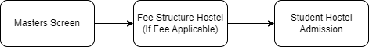
    - Table of Contents
Main Table:- TabStudent Hostel Admission
Child Table:- TabFee Structure Hostel
    - Use Case
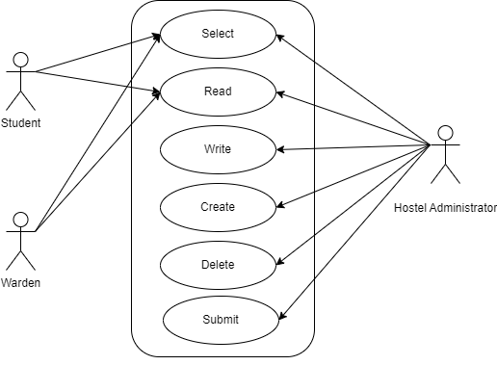
    - Form Elaboration
SL no. | Field Name | Type | Mandatory
1 | Student | Link | 1
2 | First Name | Data | 0
3 | Last Name | Data | 0
4 | Email Address | Data | 0
5 | Roll No | Data | 0
6 | Registration Number | Data | 0
7 | Current Education | Table | 0
8 | Hostel | Link | 0
9 | Allotment Status | Data | 0
10 | Hostel Phone Number 1 | Data | 0
11 | Hostel Phone Number 2 | Data | 0
12 | Hostel Type | Data | 0
13 | Room Type | Link | 1
14 | Capacity | Data | 0
15 | Type of Room | Data | 0
16 | Feature | Data | 0
17 | Is Hostel Fee Applicable | Select | 0
18 | Hostel Fee Structure | Link | 0
19 | Due Date | Date | 0
20 | Hostel Fee Components | Table | 0
21 | Hostel Fees | Data | 0

    - Screen Authorization
Sl No. | Role | Level | Select | Read | Write | Create | Delete | Submit
1 | Hostel Administrator | 0 | 1 | 1 | 1 | 1 | 1 | 1
2 | Student | 0 | 1 | 1 | 0 | 0 | 0 | 0
3 | Warden | 0 | 1 | 1 | 0 | 0 | 0 | 0

    - Component And Module
Module Related:- Education

    - Business Logic
- Go to the Student Hostel Admission list and click on New.
- Select Student, Hostel Masters, Room Type.
- Choose Yes or No in “Is Hostel Fee Applicable” .
- If you choose No then leave it as it is or,
- If you choose Yes then select “Hostel Fee Structure” and “Due Date”.
- Click on Save and Submit
    - Path of the screen
Home > Hostel > Student Admission & Essentials > Student Hostel Admission
  - Student Medical History
    - Overview
The Student Medical History help to mention about Student medical related information.
    - Description of Problem
Create a page containing all Information about student medical related information history like Allergies, Post Medical History etc.
    - Dependency
- Room Allotment
    - Flow Charts
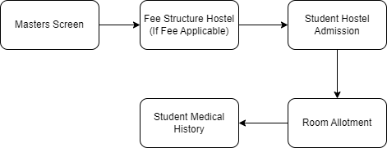
    - Table of Contents
Main Table:- TabStudent Medical History
    - Use Case
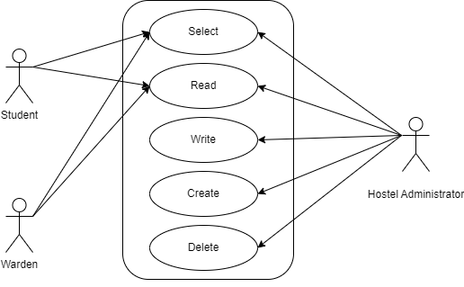
    - Form Elaboration
SL no. | Fields Name | Type | Mandatory
1 | Allotment Number | Link | 0
2 | Student | Data | 0
3 | Student Name | Data | 0
4 | Roll No | Data | 0
5 | Registration Number | Data | 0
6 | Hostel | Data | 0
7 | Room Number | Data | 0
8 | Room Type | Data | 0
9 | Aspirin | Check | 0
10 | Penicilin | Check | 0
11 | Codeine | Check | 0
12 | Local Anesthetics | Check | 0
13 | Other | Check | 0
14 | If yes, please explain | Small Text | 0
15 | Metal | Check | 0
16 | Latex | Check | 0
17 | Sulfa drugs | Check | 0
18 | Acrylic | Check | 0
19 | Myocardiac Infarction (Heart Attack) | Check | 0
20 | Heart Trouble/Disease/Packmaker | Check | 0
21 | Jaundice | Check | 0
22 | Tuberculosis | Check | 0
23 | Hypertension | Check | 0
24 | Rheumatic fever | Check | 0
25 | Epilepsy | Check | 0
26 | Asthma | Check | 0
27 | Diabetes | Check | 0
28 | Stroke | Check | 0
29 | Have you ever had any serious illness not listed above? If yes please mention below | Small Text | 0
30 | Cancer | Check | 0
31 | treatment if so | Small Text | 0
32 | Kidney Problems | Check | 0
33 | Drug Addiction | Check | 0
34 | Ulcers | Check | 0
35 | Thyroid Disease | Check | 0
36 | Stomach/Intestinal Disease | Check | 0
37 | Dental Problems | Check | 0
38 | Covid 19 | Check | 0
39 | Medical History Document | Section Break | 0
40 |  | Attach | 0
41 | Description | Small Text | 0
42 | Covid 19 Vaccination | Section Break | 0
43 | Vaccinated? | Select | 0
44 | First Dose | Check | 0
45 | Attach 1st Dose Certificate | Attach | 0
46 | Second Dose | Check | 0
47 | Attach 2nd Dose Certificate | Attach | 0

    - Screen Authorization
Sl No. | Role | Level | Select | Read | Write | Create | Delete | Submit
1 | Hostel Administrator | 0 | 1 | 1 | 1 | 1 | 1 | 0
2 | Student | 0 | 1 | 1 | 0 | 0 | 0 | 0
3 | Warden | 0 | 1 | 1 | 0 | 0 | 0 | 0

    - Component And Module
Module Related:- Education

    - Business Logic
- Go to the Student Medical History list and click on New.
- Select Allotment Number, according to that all data going to fetch.
- Check Allergies, Post Medical History and give full information if student had any serious illness.
- Attach Document
- Give information about Covid Vaccination and attach document.
- Click on Save
    - Path of the screen
Home > Hostel > Student Admission & Essentials > Student Medical History
  - Student Leave Process
    - Overview
The Student Leave process is allow to apply hostel leave by student.
    - Description of Problem
Create a page containing all Information for issuing leave for Student.
    - Dependency
Before creating an Student Leave Process, it is advisable to first create the following:
- Room Allotment
    - Flow Charts
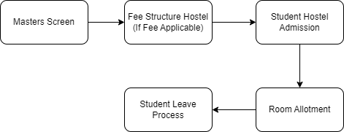
    - Table of Contents
Main Table:- tabStudent Leave Process
    - Use Case Diagram
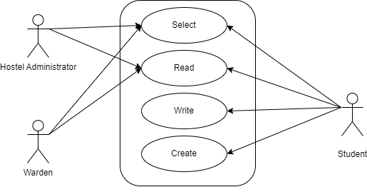
    - Form Elaboration
Sl No. | Field Name | Type | Mandatory
1 | Allotment Number | Link | 0
2 | Student | Data | 0
3 | Student Name | Data | 0
4 | Roll No | Data | 0
5 | Registration Number | Data | 0
6 | Start Date | Date | 1
7 | Hostel | Data | 0
8 | Room Number | Data | 0
9 | Room Type | Data | 0
10 | End Date | Date | 1
11 | Leave Approval Process | Section Break
12 | Application | Long Text | 0
13 | Parent Application | Attach | 0

    - Screen Authorization
Sl No. | Role | Level | Select | Read | Write | Create | Delete | Submit
1 | Hostel Administrator | 0 | 1 | 1 | 0 | 0 | 0 | 0
2 | Student | 0 | 1 | 1 | 1 | 1 | 0 | 0
3 | Warden | 0 | 1 | 1 | 0 | 0 | 0 | 0

6.9.9 Component And Module
Module Related:- Education

6.9.10 Business Logic
- Go to the Student Leave Process list and click on New.
- Select Allotment Number
- All other fields are auto fetched accordingly
- Enter Start date, End date.
- Write Application in text.
- Add attachment
- Click on Save

6.9.11 Path of the screen
Home > Hostel > Student Admission & Essentials > Student Leave Process
  - Material Distribution
    - Overview
The Material Distribution is allow to maintain item which is distributed to student for the first time like bed, chair, table etc.
    - Description of Problem
Create a page containing all Information for issuing items for Student.
    - Dependency
Room Allotment
    - Flow Charts
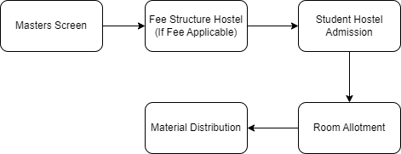
    - A Table of Contents
- Main Table name :- TabMaterial Distribution
    - Use Case Diagram
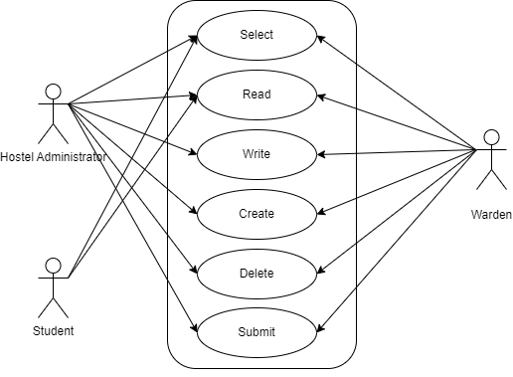
    - Form Elaboration
Sl No. | Fields | Type | Mandatory
1 | Allotment Number | Link | 0
2 | Student | Data | 0
3 | Student Name | Data | 0
4 | Roll No | Data | 0
5 | Registration Number | Data | 0
6 | Hostel | Data | 0
7 | Room Number | Data | 0
8 | Room Type | Data | 0
9 | Bed / Cot | Check | 0
10 | Matress | Check | 0
11 | Table | Check | 0
12 | Chair | Check | 0
13 | Bucket | Check | 0
14 | Mug | Check | 0
15 | Pillow | Check | 0
16 | Blanket | Check | 0
17 | Bedsheet cum Pillow cover | Check | 0
18 | Notes | Long Text | 0

    - Screen Authorization
Sl No. | Role | Level | Select | Read | Write | Create | Delete | Submit
1 | Hostel Administrator | 0 | 1 | 1 | 1 | 1 | 1 | 1
2 | Student | 0 | 1 | 1 | 0 | 0 | 0 | 0
3 | Warden | 0 | 1 | 1 | 1 | 1 | 1 | 1

    - Component And Module
Module Related:- Education

    - Business Logic
- Go to the Material Distribution list and click on new
- Select Allotment Number.
- All other fields are auto fetched accordingly
- Check Material which is given to that student.
- Enter a Notes.
- Click on Save and Submit
    - Path of the screen
Home > Hostel > Student Admission & Essentials > Material Distribution

6.11 Room Allotment

6.11.1 Overview
The Room Allotment is the process where student will get their confirmation for hostel and room.In this Student will get Hostel room what they want in Admission time. If that Hostel room not present then able to change through Room allotment.

6.11.2 Description of Problem
.Create a page containing all Information about allotment details for student.

6.11.3 Dependency
Dependent on following Form:
- Student
- Hostel Masters
- Room Masters

6.11.4 Flow Charts
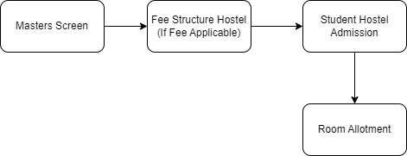

6.11.5 A Table of Contents
- Main Table name :- TabRoom Allotment

6.11.6 Use Case Diagram
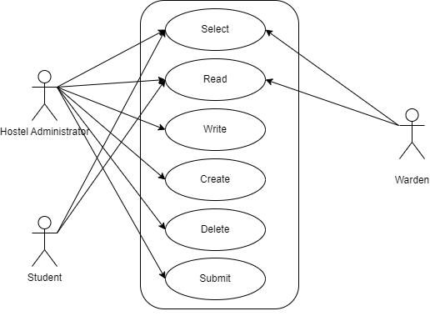

6.11.7 Form Elaboration
Sl No. | Fields | Type | Mandatory
1 | Student | Link | 1
2 | Date of Birth | Data
3 | Room Type Reference | Data
4 | Student Name | Data
5 | Roll No | Data
6 | Registration Number | Data
7 | Blood Group | Data
8 | Hostel Registration No. | Link
9 | Hostel | Link | 1
10 | Start Date | Date
11 | End Date | Date
12 | Allotment Type | Data
13 | Room ID | Link | 1
14 | Room Number | Data
15 | Room Type | Data
16 | Addon Facilites | Data
17 | Father's Name | Data
18 | Father's Contact Number | Data
19 | Father's Occupation | Data
20 | Father's Annual Income | Data
21 | Mother's Name | Data
22 | Mother's Contact Number | Data
23 | Mother's Occupation | Data
24 | Mother's Annual Income | Data
25 | Local Guardian's Name | Data
26 | Local Guardian's Contact No. | Data
27 | Local Guardian's Address | Data
28 | Relation with Student | Data
29 | Employee | Link
30 | Designation | Data
31 | Employee Name | Data
32 | Contact Number | Data

6.11.8 Screen Authorization
Sl No. | Role | Level | Select | Read | Write | Create | Delete | Submit
1 | Hostel Administrator | 0 | 1 | 1 | 1 | 1 | 1 | 1
2 | Student | 0 | 1 | 1 | 0 | 0 | 0 | 0
3 | Warden | 0 | 1 | 1 | 0 | 0 | 0 | 0

6.11.9 Component And Module
Module Related:- Education

6.11.10 Business Logic
- Go to Room Allotment list, Click on new.
- Select Student, hostel and Room Id.
- According to that all data are going to fetch.
- Click on Save and Submit.

6.11.11 Path of the screen
Home > Hostel > Allotment & De-Allotment > Room Allotment

6.12. Room De-Allotment

6.12.1 Overview
The Room De-Allotment is the process where student are de-alloted from hostel and room.

6.12.2 Description of Problem
Create a form to containing all Information about De-alloted Student.

6.12.3 Dependency
- Room Allotment

6.12.4 Flow Charts
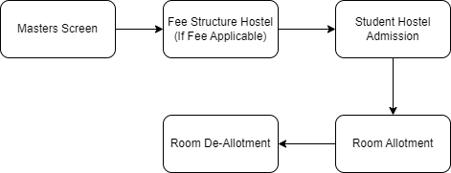

6.12.5 Table of Contents
- Main Table name :- TabDeallotment Process
- Child Table name :-
- TabDeallotment Fee Waiver Components

6.12.6 Use Case Diagram

6.12.7 Form Elaboration
Sl No. | Field Name | Type | Mandatory
1 | Allotment Number | Link | 1
2 | Student | Data
3 | Student Name | Data
4 | Roll No | Data
5 | Registration Number | Data
6 | Hostel | Data
7 | Room No. | Data
8 | Room Type | Data
9 | Guardian's Application | Attach
10 | Student's Application | Attach
11 | Address Proof | Attach
12 | End Date | Date
13 | Hostel Fees | Link
14 | Fees | Data
15 | Hostel Fee Structure | Link
16 | Components | Table

6.12.8 Screen Authorization
Sl No. | Role | Level | Select | Read | Write | Create | Delete | Submit
1 | Hostel Administrator | 0 | 1 | 1 | 1 | 1 | 1 | 1
2 | Student | 0 | 1 | 1 | 0 | 0 | 0 | 0
3 | Warden | 0 | 1 | 1 | 0 | 0 | 0 | 0

6.12.9 Component And Module
Module Related:- Education

6.12.10 Business Logic
- Go to Room De-Allotment list and click on new.
- Select Allotment Number, Which student you want to de-allot.
- Accordingly all data going to fetch.
- Add attachment and enter end date.
- Click on save.
- After that select action button on top right side.
- There are four option given Approve, Review, Reject and Withdrawal
- Select one off them for complete the process.
- Accordingly status will updated.

6.12.11 Path of the screen
Home > Hostel > Allotment & De-Allotment > Room De-Allotment

6.13. Room Change

6.13.1 Overview
The Room Change is the process where student apply to transfer their room from one to another.

6.13.2 Description of Problem
Create a form to containing all Information about student transferring room.

6.13.3 Dependency
- Room Allotment
- Hostel Masters
- Room Masters

6.13.4 Flow Charts
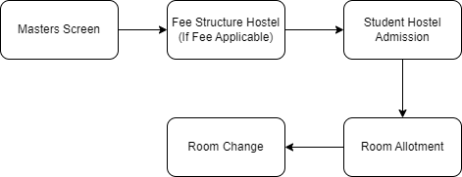

6.13.5 Table of Contents
- Main Table name :- TabRoom Changes

6.13.6 Use Case Diagram
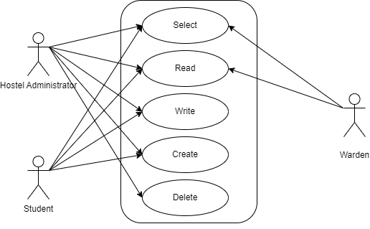

6.13.7 Form Elaboration
Sl No. | Field Name | Type | Mandatory
1 | Allotment Number | Link | 1
2 | Student | Data
3 | Student Name | Data
4 | Roll No | Data
5 | Registration Number | Data
6 | Hostel | Data
7 | Room No. | Data
8 | Room Type | Data
9 | Preferred Hostel | Link
10 | Preferred Room | Link
11 | Preferred Room Type | Data
12 | Preferred Room Number | Data
13 | Application | Attach
14 | Application | Long Text

6.13.8 Screen Authorization
Sl No. | Role | Level | Select | Read | Write | Create | Delete | Submit
1 | Hostel Administrator | 0 | 1 | 1 | 1 | 1 | 1 | 0
2 | Student | 0 | 1 | 1 | 0 | 0 | 0 | 0
3 | Warden | 0 | 1 | 1 | 1 | 1 | 0 | 0

6.13.9 Component And Module
Module Related:- Education

6.13.10 Business Logic
- Gp to Room Change list and click on new.
- Select Allotment Number, Preferred Hostel, Preferred Room.
- Accordingly all data going to fetch.
- Add Attachment
- Enter Application.
- Click on Save.
- After that Approver will approved this form.

6.13.11 Path of the screen
Home > Hostel > Allotment & De-Allotment > Room Change/ Room Type Change

6.14. Death De-Allotment

6.14.1 Overview
Death De-Allotment is the process where student de-alloted from hostel after his death.

6.14.2 Description of Problem
Create a form to containing all Information about student de-allotment.

6.14.3 Dependency
- Room Allotment
- Employee

6.14.4 Flow Charts
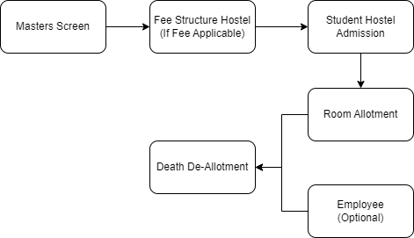

6.14.5 Table of Contents
- Main Table name :- TabDeath Deallotment

6.14.6 Use Case Diagram
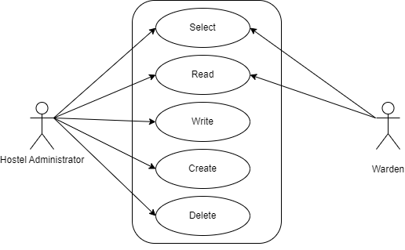

6.14.7 Form Elaboration
Sl No. | Field Name | Type | Mandatory
1 | Allotment No | Link | 1
2 | Student | Link
3 | Date of Birth | Data
4 | Student Name | Data
5 | Roll No | Data
6 | Registration Number | Data
7 | Blood Group | Data
8 | Hostel Name | Data
9 | Room Type | Data
10 | Room No | Data
11 | Father's Name | Data
12 | Father's Contact Number | Data
13 | Mother's Name | Data
14 | Mother's Contact Number | Data
15 | Employee | Link
16 | Designation | Data
17 | Employee Name | Data
18 | Contact Number | Data
19 | Attachment | Attach

6.14.8 Screen Authorization
Sl No. | Role | Level | Select | Read | Write | Create | Delete | Submit
1 | Hostel Administrator | 0 | 1 | 1 | 1 | 1 | 1 | 1
2 | Warden | 0 | 1 | 1 | 0 | 0 | 0 | 0

6.14.9 Component And Module
Module Related:- Education

6.14.10 Business Logic
- Go to Death Deallotment list and click on new.
- Select Allotment No, Employee.
- Accordingly all data fetch
- Enter Date of Demise and Reason of Demice
- Attach Document
- Click on Save and Submit

6.14.11 Path of the screen
Home > Hostel > Allotment & De-Allotment > Death De-Allotment

6.15. Long Leave

6.15.1 Overview
A long leave in a hostel typically refers to an extended absence from the hostel, usually for a period of several weeks or months. This may be due to a variety of reasons, such as academic breaks, travel plans, personal reasons, or medical issues.
During a long leave, the hostel resident typically vacates their room or bed and temporarily suspends their membership or agreement with the hostel.

6.15.2 Description of Problem
Create a form to containing all Information about Student and Administrator communication record.

6.15.3 Dependency
- Room Allotment

6.15.4 Flow Charts
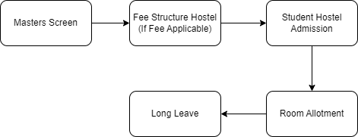

6.15.5 A Table of Contents
- Main Table name :- TabLong Leave

6.15.6 Use Case Diagram
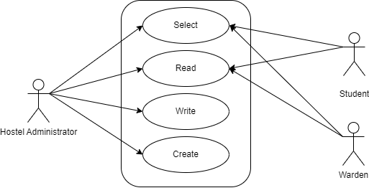

6.15.7 Form Elaboration
Sl No. | Field Name | Type | Mandatory
1 | Allotment Number | Link
2 | Student | Data
3 | Student Name | Data
4 | Roll No | Data
5 | Registration Number | Data
6 | Hostel | Data
7 | Room Number | Data
8 | Room Type | Data
9 | Start Date | Date | 1
10 | Status | Data
11 | Medium of Communication | Select
12 | Letter Attacmnent | Attach
13 | Email Attachment | Attach
14 | Phone No | Phone
15 | Email Id | Data
16 | Address Line 1 | Data
17 | Address Line 2 | Data
18 | Pincode | Data
19 | City | Data
20 | State | Data
21 | Medium of Communication From Student | Select
22 | Letter Attacmnent | Attach
23 | Email | Data
24 | Communication Phone no | Phone
25 | Address Line 1 | Data
26 | Address Line 2 | Data
27 | Pincode | Data
28 | City | Data
29 | State | Data
30 | Reply of Letter | Attach

6.15.8 Screen Authorization
Sl No. | Role | Level | Select | Read | Write | Create | Delete | Submit
1 | Hostel Administrator | 0 | 1 | 1 | 1 | 1 | 0 | 0
2 | Student | 0 | 1 | 1 | 0 | 0 | 0 | 0
3 | Warden | 0 | 1 | 1 | 0 | 0 | 0 | 0

6.15.9 Component And Module
Module Related:- Education

6.15.10 Business Logic
- Go to Long Leave List and click on new.
- Select Allotment Number according to that all data fetch
- Enter Start date
- Give medium of communication and attach document
- Click on Save

6.15.11 Path of the screen
Home > Hostel > Allotment & De-Allotment > Long Leave

6.16 Inter or Intra Hostel Change

6.16.1 Overview
An inter-hostel change refers to a situation where a person moves from one hostel to another, whereas an intra-hostel change refers to a situation where a person moves from one room to another within the same hostel.

6.16.2 Description of Problem
Create a form to containing all Information about hostel transfer detail.

6.16.3 Dependency
- Room Allotment

6.16.4 Flow Charts
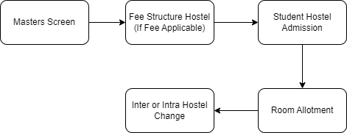

6.16.5 A Table of Contents
Main Table name :- TabInter or Intra Hostel Change

6.16.6 Use Case Diagram

6.16.7 Form Elaboration
Sl No. | Field Name | Type | Mandatory
1 | 1st Allotment No | Link | 1
2 | 1st Student Name | Data
3 | 1st Hostel Name | Data
4 | 1st Room No | Data
5 | 1st Room Type | Data
6 | 1st Allotment Type | Data
7 | 1st Student Application | Attach
8 | 2nd Allotment No | Link | 1
9 | 2nd Student Name | Data
10 | 2nd Hostel Name | Data
11 | 2nd Room No | Data
12 | 2nd Room Type | Data
13 | 2nd Allotment Type | Data
14 | 2nd Student Application | Attach

6.16.8 Screen Authorization
Sl No. | Role | Level | Select | Read | Write | Create | Delete | Submit
1 | Hostel Administrator | 0 | 1 | 1 | 1 | 1 | 0 | 0
2 | Student | 0 | 1 | 1 | 0 | 0 | 0 | 0
3 | Warden | 0 | 1 | 1 | 0 | 0 | 0 | 0

6.16.9 Component And Module
Module Related:- Education

6.16.10 Business Logic
- Go to Inter or Intra Hostel Change and click on new.
- Select 1st Allotment No and 2nd Allotment No
- Accordingly all data fetch
- Add Attachment
- Click on Save

6.16.11 Path of the screen
Home > Hostel > Allotment & De-Allotment > Inter or Intra Hostel Change

6.17 Hostel Fee Structure

6.17.1 Overview
Hostel Fee Structure is the process where we define the fee Category and their charges of the hostel.

6.17.2 Description of Problem
Create a form to containing all Information about hostel fees.

6.17.3 Dependency
- Program
- Semester
- Fee type
- Room type
- Academic term
- Academic Year
- Fee Category
- Account

6.17.4 Table of Contents
Main Table name :- TabFee Structure Hostel
Child Table Name:- TabFee Component

6.17.5 Use Case Diagram
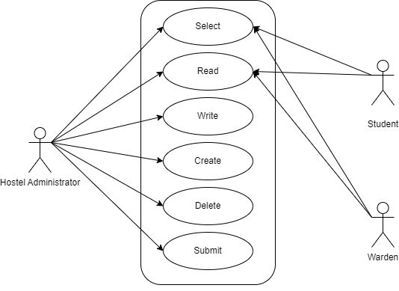

6.17.6 Form Elaboration
Sl No. | Field Name | Type | Mandatory
1 | Naming Series | Select
2 | Programs | Link | 1
3 | Program | Link | 1
4 | Fee Type | Link | 1
5 | Room Type | Link | 1
6 | Academic Year | Link | 1
7 | Academic Term | Link | 1
8 | Components | Table | 1
9 | Total Amount | Currency
10 | Receivable Account | Link
11 | Income Account | Link
12 | Company | Link
13 | Cost Center | Link

6.17.7 Screen Authorization
Sl No. | Role | Level | Select | Read | Write | Create | Delete | Submit
1 | Hostel Administrator | 0 | 1 | 1 | 1 | 1 | 1 | 1
2 | Student | 0 | 1 | 1 | 0 | 0 | 0 | 0
3 | Warden | 0 | 1 | 1 | 0 | 0 | 0 | 0

6.17.8 Component And Module
Module Related:- Education

6.17.9 Business Logic
- Go to the Fee Structure Hostel list, click on Add Fee Structure Hostel.
- Select and add the Program, Fee Type and other details for the fee structure hostel.
- In the Components Table,
a) Enter the Fees Category and Amount.
b) Select Waiver Type as a Percentage or Amount then after New Filed will fetch.
c) You can add your Accounts details in the fee structure like Receivable Account,Income Account and Company.
- Click on Save and submit.
- Once you have submitted the Fee Structure hostel, you will be able to create the hostel Fee Schedule from within Fee Structure Hostel.

6.17.10 Path of the screen
Home > Hostel > Hostel Fees > Hostel Fee Structure

6.18 Hostel Fee Schedule

6.18.1 Overview
Hostel Fee Schedule is the process where we charge hostel fees in bulk.

6.18.2 Description of Problem
Create a form to containing all Information about student and their hostel fees.

6.18.3 Dependency
- Programs
- Academic Year
- Fee Structure Hostel
- Student

6.16.4 Flow Charts
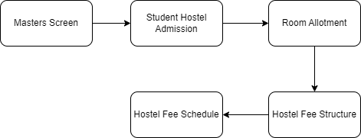

6.18.5 Table of Contents
Main Table name :- TabHostel Fee Schedule
Child Table Name :-
        - TabHostel Fee Schedule Student
        - TabFee Component

6.18.6 Use Case Diagram
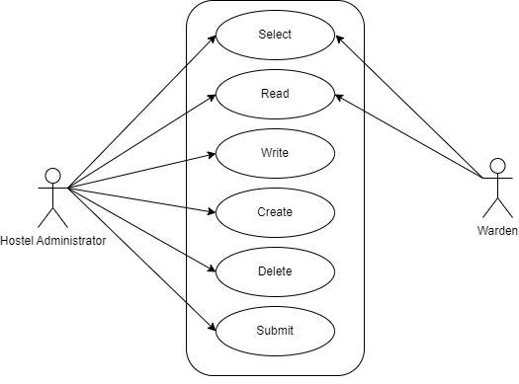

6.18.7 Form Elaboration
Sl No. | Field Name | Type | Mandatory
1 | Program Filter | Link | 1
2 | Academic Year Filter | Link | 1
3 | Fee Structure | Link | 1
4 | Naming Series | Select
5 | Posting Date | Date | 1
6 | Due Date | Date | 1
7 | Fee Creation Status | Select
8 | Room Type | Link
9 | Programs | Link
10 | Program | Link
11 | Academic Year | Link | 1
12 | Academic Term | Link
13 | Get Students | Button
14 |  | Table
15 | Fee Component | Table
16 | Total Amount per Student | Currency
17 | Grand Total | Currency
18 | In Words | Data
19 | Letter Head | Link
20 | Print Heading | Link
22 | Institution | Link
23 | Cost Center | Link

6.18.8 Screen Authorization
Sl No. | Role | Level | Select | Read | Write | Create | Delete | Submit
1 | Hostel Administrator | 0 | 1 | 1 | 1 | 1 | 1 | 1
2 | Warden | 0 | 1 | 1 | 0 | 0 | 0 | 0

6.18.9 Component And Module
Module Related:- Education

6.18.10 Business Logic
- Go to the Hostel Fee Schedule list and click on Add Hostel Fee Schedule.
- Select and add the Fee Structure. The moment you add the Fee Structure, the Fee Break Up for Each Student will be auto-populated.
- Add the Due Date for the fees.
- Click on Get Student button then all student fetch whose room are allotted.
- Click on Save and Submit.
- Once you have submitted the Hostel Fee Schedule, you will be able to create the Hostel Fees from within Hostel Fee Schedule.
- You ca able to view Account ledger through button.
- You can able to go hostel Fees record through button.

6.18.11 Path of the screen
Home > Hostel > Hostel Fees > Hostel Fee Schedule

6.19 Hostel Fees

6.19.1 Overview
Hostel Fees is the process where we can maintain the Hostel Fee Records of the students.

6.19.2 Description of Problem
Create a form to containing all Information about Student fee records.

6.19.3 Dependency
- Student
- Fee Structure Hostel
- Fees Category

6.19.4 Flow Charts
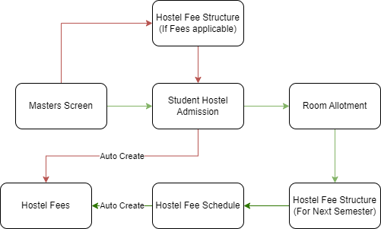

6.19.5 A Table of Contents
Main Table name :- TabHostel Fees
Child Table Name:- TabFee Component

6.19.6 Use Case Diagram

6.19.7 Form Elaboration
Sl No. | Field Name | Type | Mandatory
1 | Student | Link | 1
2 | Student Name | Data
3 | Roll No | Data
4 | Registration Number | Data
5 | Valid From | Date
6 | Valid To | Date
7 | Institution | Link | 1
8 | Date | Date | 1
9 | Posting Time | Time
10 | Due Date | Date | 1
11 | Hostel Admission | Data | 1
12 | Allotment Number | Data
13 | Hostel | Data
14 | Room Number | Data
15 | Room Type | Data
16 | Amended From | Link
17 | Program Enrollment | Link
18 | Programs | Link | 1
19 | Program | Link | 1
20 | Student Batch | Link
21 | Student Email | Data
22 | Student Category | Link
23 | Academic Term | Link
24 | Academic Year | Link
25 | Hostel Fee Structure | Link | 1
26 | Components | Table | 1
27 | Grand Total | Currency
28 | In Words | Data
29 | Outstanding Amount | Currency
30 | Letter Head | Link
31 | Print Heading | Link
32 | Cost Center | Link
33 | Fees | Link
34 | Hostel Fee Schedule | Link

6.19.8 Screen Authorization
Sl No. | Role | Level | Select | Read | Write | Create | Delete | Submit
1 | Hostel Administrator | 0 | 1 | 1 | 1 | 1 | 1 | 1
2 | Student | 0 | 1 | 1 | 0 | 0 | 0 | 0
3 | Warden | 0 | 1 | 1 | 0 | 0 | 0 | 0

6.19.9 Component And Module
Module Related:- Education

6.19.10 Business Logic
1. Go to the Hostel Fees list and click on Add.
2. The Institution will be selected by default, which is editable, if required.
3. Select and add the Student for whom the Hostel Fees record is being made.The name of the student will be fetched simultaneously.
4. Add the Due Date of the payment of the Hostel Fees and select Hostel fee Structure.
5. Click on Save and Submit.
6. Once you submitted the Hostel fees, you can able to view in fees record. Throgh Fees form able to create the payment entry
7. You can able to view Ledger through button.
8. You can able to create Hostel Fees through :
a) Hostel Student Admission
b) Hostel Fee Schedule

6.19.11 Path of the screen
Home > Hostel > Hostel Fees > Hostel Fees

6.20 Indisciplinary Complaint Registration

6.20.1 Overview
Indisciplinary Complaint Registration is the process where filed complaint against Student for some misbehave.

6.20.2 Description of Problem
Create a form to containing all Information about student misbehave description and reporting date with higher authority.

6.20.3 Dependency
- Employee
- Room Allotment

6.20.4 Flow Charts
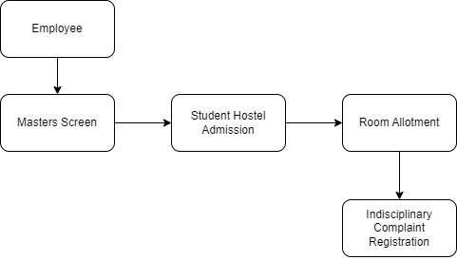

6.20.5 A Table of Contents
Main Table name :- TabIndisciplinary Complaint Registration
Child Table Name:- TabIndisciplinary Complaint Registration Student

6.20.6 Use Case Diagram
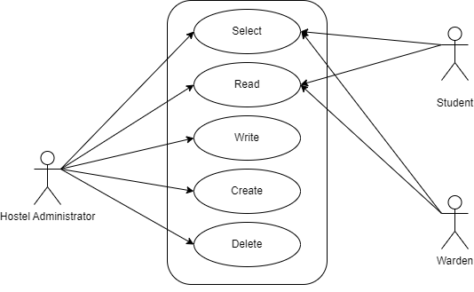

6.20.7 Form Elaboration
Sl No. | Field Name | Type | Mandatory
1 | Employee | Link | 1
2 | Employee Name | Data
3 | Previous Complaint ID | Link
4 | Reporting Date | Date | 1
5 | Status | Select
6 | Description | Long Text | 1
7 | Attach File | Attach
8 | Student | Table | 1

6.20.8 Screen Authorization
Sl No. | Role | Level | Select | Read | Write | Create | Delete | Submit
1 | Hostel Administrator | 0 | 1 | 1 | 1 | 1 | 1 | 0
2 | Student | 0 | 1 | 1 | 0 | 0 | 0 | 0
3 | Warden | 0 | 1 | 1 | 0 | 0 | 0 | 0

6.20.9 Component And Module
Module Related:- Education

6.20.10 Business Logic
- Go to Indisciplinary Complaint Registration list and click on new
- Select Employee and Previous Complaint Id.
- Enter Reporting Date, Description
- Add attachment
- Add student in child table
- Click on save

6.20.11 Path of the screen
Home > Hostel > Disciplinary Committee Processes > Indisciplinary Complaint Registration

6.21 Indisciplinary Actions

6.21.1 Overview
Indisciplinary Actions is the process where action will taken for student according to Committee discussion.

6.21.2 Description of Problem
Create a form to containing all Information about action decision

6.21.3 Dependency
- Indisciplinary Complaint Registration

6.21.4 Flow Charts
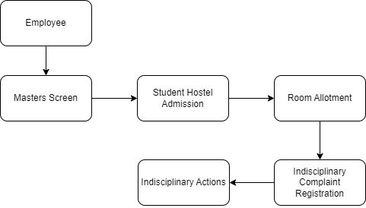

6.21.5 Use Case Diagram

6.21.6 Table of Contents
Main Table Name:- TabIndisciplinary Action
Child Table Name:-
      - TabIndisciplinary Complaint Registration Student
      - TabDC Members

6.21.7 Form Elaboration
Sl No. | Field Name | Type | Mandatory
1 | Indisciplinary Complaint Registration ID | Link
2 | Type of Decision | Select | 1
3 | Description | Long Text
4 | Attachment | Attach
5 | Student | Table
6 | Date of Warning Letter | Date
7 | Attachment of Warning Letter | Attach
8 | Local Dispatch Warning Letter | Data
9 | Issue of Fine Letter | Date
10 | Attachment of Fine Letter | Attach
11 | Local Dispatch Fine Letter | Data
12 | Fine Amount | Currency
13 | Issue of Suspension Letter | Date
14 | Local Dispatch Suspension Letter | Data
15 | Attachment of Suspension Letter | Attach
16 | Type of Suspension | Select
17 | Issue of DC Letter | Date
18 | Local Dispatch DC Letter | Data
19 | DC members | Table
20 | Attachment of DC Letter | Attach
21 | Issue of Debar Letter | Date
22 | Attachment of Debar Letter | Attach
23 | Local Dispatch Debar Letter | Data
24 | Issue of Parents Call Letter | Date
25 | Attachment of Parents Call Letter | Attach
26 | Parents Meeting Date | Date
27 | Parents Undertaking | Attach
28 | Local Dispatch Parents Call Letter | Data

6.21.8 Screen Authorization
Sl No. | Role | Level | Select | Read | Write | Create | Delete | Submit
1 | Hostel Administrator | 0 | 1 | 1 | 1 | 1 | 1 | 1
2 | Student | 0 | 1 | 1 | 0 | 0 | 0 | 0
3 | Warden | 0 | 1 | 1 | 0 | 0 | 0 | 0

6.21.9 Components And Modules
Module Related:- Education

6.21.10 Business Logic
- Go to Indisciplinary Actions and click on new
- Select Indisciplinary Complaint Registration ID and Type of Decision
- There are four type of decisions. According to that field will fetch and you need to fill that field accordingly.
- Click on Save and Submit

6.21.11 Path of the screen
Home > Hostel > Disciplinary Committee Processes > Indisciplinary Actions

6.22 Disciplinary Committee Meeting

6.22.1 Overview
Disciplinary Committee Meeting is the process where we maintain all information about complaint.

6.22.2 Description of Problem
Create a form to containing all Information about involvement of student, when did it occur and etc.

6.22.3 Dependency
- Indisciplinary Actions

6.22.4 Flow Charts
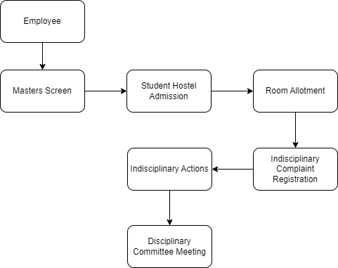

6.22.5 Use Case Diagram
6.21.6 Table of Contents
Main Table Name:- TabDisciplinary Committee Meeting
Child Table Name:-
      - TabDC Members
      - TabIndisciplinary Complaint Registration Student

6.22.7 Form Elaboration
Sl No. | Field Name | Type | Mandatory
1 | Indisciplinary Actions ID | Link
2 | DC Members | Table
3 | Indisciplinary Complaint Registration ID | Data
4 | Student | Table
5 | Employee | Data
6 | Reporting Date | Data
7 | Status | Data
8 | Previous Complaint ID | Data
9 | Description | Data
10 | Attach Docs | Data
11 | WHEN DID IT OCCUR? | Small Text
12 | WHO ALL WERE INVOLVED? | Small Text | 1
13 | WHERE DID IT OCCUR? | Small Text | 1
14 | WHAT HAPPENED? | Small Text | 1
15 | WHY IS THIS A GRIEVANCE? | Small Text
16 | WHAT ADJUSTMENT IS REQUIRED? | Small Text
17 | ADDITIONAL COMMENTS | Small Text

6.22.8 Screen Authorization
Sl No. | Role | Level | Select | Read | Write | Create | Delete | Submit
1 | Hostel Administrator | 0 | 1 | 1 | 1 | 1 | 1 | 1
2 | Student | 0 | 1 | 1 | 0 | 0 | 0 | 0
3 | Warden | 0 | 1 | 1 | 0 | 0 | 0 | 0

6.22.9 Components And Modules
Module Related:- Education

6.22.10 Business Logic
- Go to Disciplinary Committee Meeting list and click on new
- Select Indisciplinary Actions, through all data
- Give full description about Meeting and add attachment.
- Click on Save and Submit

6.22.11 Path of the screen
Home > Hostel > Disciplinary Committee Processes > Disciplinary Committee Meeting

6.23 Withdrawal of Suspension

6.23.1 Overview
Withdrawal of Suspension is a process where student suspension will revoke

6.23.2 Description of Problem
Create a form to containing all Information about Student revoke suspension.

6.23.3 Dependency
- Indisciplinary Actions
- Disciplinary Committee Meeting

6.23.4 Flow Charts
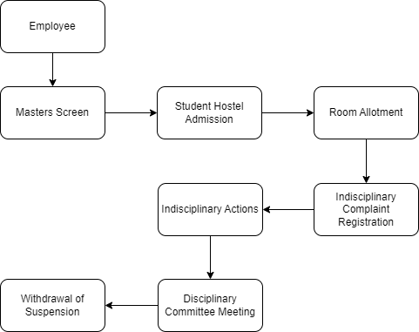

6.23.5 Use Case Diagram
6.21.6 Table of Contents
Main Table Name:- TabWithdrawal of Suspension

6.23.7 Form Elaboration
Sl No. | Field Name | Type | Mandatory
1 | Indisciplinary Action ID | Link
2 | Type of Decision | Data
3 | Description | Data
4 | Complaint Attachment | Data
5 | Indisciplinary Complaint Registration ID | Data
6 | Issue of Suspension Letter | Data
7 | Local Dispatch Suspension Letter | Data
8 | Attachment of Suspension Letter | Data
9 | Type of Suspension | Data
10 | Student | Table
11 | Issue of Withdrawal Letter | Date | 1
12 | Local Dispatch of Withdrawal Letter | Data
13 | Attach Withdrawal Letter | Attach | 1

6.23.8 Screen Authorization
Sl No. | Role | Level | Select | Read | Write | Create | Delete | Submit
1 | Hostel Administrator | 0 | 1 | 1 | 1 | 1 | 1 | 1
2 | Student | 0 | 1 | 1 | 0 | 0 | 0 | 0
3 | Warden | 0 | 1 | 1 | 0 | 0 | 0 | 0

6.23.9 Components And Modules
Module Related:- Education

6.23.10 Business Logic
- Go to Withdrawal of Suspension list and click on new
- Select Indisciplinary Actions through that all data fetch
- Enter Issue of withdrawal letter and local dispatch of withdrawal letter
- Attach document
- Click on Save and Submit

6.23.11 Path of the screen
Home > Hostel > Disciplinary Committee Processes > Withdrawal of Suspension

6.24 Hostel Suspension Room Change

6.24.1 Overview
Hostel Suspension Room Change is the process where student transfer to another hostel or room as a punishment.

6.24.2 Description of Problem
Create a form to containing all Information about transfer hostel or room.

6.24.3 Dependency
- Room Allotment
- Indisciplinary Actions
- Hostel Masters
- Room Masters

6.24.4 Flow Charts
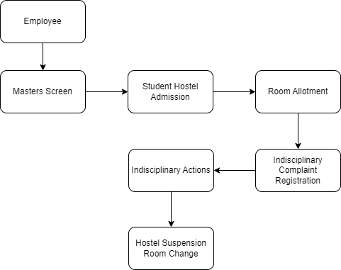

6.24.5 Use Case Diagram

6.21.6 Table of Contents
Main Table Name:- TabHostel Suspension Room Change

6.24.7 Form Elaboration
Sl No. | Field Name | Type | Mandatory
1 | Allotment Number | Link | 1
2 | Student | Data
3 | Student Name | Data
4 | Roll No | Data
5 | Registration Number | Data
6 | Hostel | Data
7 | Room Number | Data
8 | Allotment Type | Data
9 | Room Type | Data
10 | Preferred Hostel | Link | 1
11 | Preferred Room | Link | 1
12 | Preferred Room Type | Data
13 | Preferred Room Number | Data
14 | Indisciplinary Actions ID | Link | 1
15 | Indisciplinary Complaint Registration ID | Data
16 | Issue of Suspension Letter | Data
17 | Attachment of Suspension Letter | Data
18 | Type of Suspension | Data

6.24.8 Screen Authorization
Sl No. | Role | Level | Select | Read | Write | Create | Delete | Submit
1 | Hostel Administrator | 0 | 1 | 1 | 1 | 1 | 1 | 1
2 | Student | 0 | 1 | 1 | 0 | 0 | 0 | 0
3 | Warden | 0 | 1 | 1 | 0 | 0 | 0 | 0

6.24.9 Components And Modules
Module Related:- Education

6.24.10 Business Logic
- Go to Hostel Suspension Room Change list and click on new
- Select Allotment Number, Preferred Hostel, Preferred Room and indisciplinary Actions Id
- Accordingly all data going to fetch
- Click on Save and Submit

6.24.11 Path of the screen
Home > Hostel > Disciplinary Committee Processes > Hostel Suspension Room Change

6.25 Inward Suspension Letter

6.25.1 Overview
Inward Suspension letter is the process where we maintain Academic Suspension. Through that he/she will not be part of any activity in hostel.

6.25.2 Description of Problem
Create a form to containing all Information about Student academic suspension.

6.25.3 Dependency
- Student
- Room Allotment
- Employee

6.25.4 Flow Charts
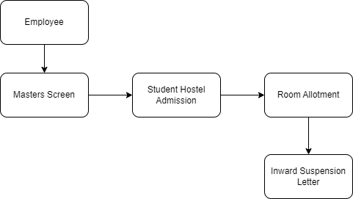

6.25.5 Use Case Diagram

6.21.6 Table of Contents
Main Table Name:- TabInward Suspension Letter
Child Table name:- TabInward Suspension Letter Student

6.25.7 Form Elaboration
Sl No. | Field Name | Type | Mandatory
1 | Local Dispatch Number | Data
2 | Suspension Type | Select | 1
3 | Employee | Link
4 | Attach Copy of the Order | Attach | 1
5 | Date of the Order | Date | 1
6 | Employee Name | Data
7 | Students | Table | 1

6.25.8 Screen Authorization
Sl No. | Role | Level | Select | Read | Write | Create | Delete | Submit
1 | Hostel Administrator | 0 | 1 | 1 | 1 | 1 | 1 | 1
2 | Student | 0 | 1 | 1 | 0 | 0 | 0 | 0
3 | Warden | 0 | 1 | 1 | 0 | 0 | 0 | 0

6.25.9 Components And Modules
Module Related:- Education

6.25.10 Business Logic
- Go to Inward Suspension Letter and click on new
- Enter Local Dispatch Number, Date of the Order
- Select Suspension type and Employee
- Enter Student Child Table data
- Click on Save and Submit

6.25.11 Path of the screen
Home > Hostel > Disciplinary Committee Processes > Inward Suspension Letter

6.26 Withdrawal of Inward Suspension Letter

6.26.1 Overview
Withdrawal of Inward Suspension Letter is the process where we revoke student suspension.

6.26.2 Description of Problem
Create a form to containing all Information about revoke student suspension.

6.26.3 Dependency
- Inward Suspension Letter

6.26.4 Flow Charts
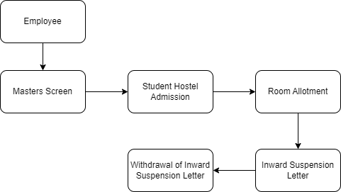

6.26.5 Use Case Diagram
6.26.6 Table of Contents
Main Table name:- TabWithdrawal of Inward Suspension Letter
Child Table name:- TabInward Suspension Letter Student

6.26.7 Form Elaboration
Sl No. | Field Name | Type | Mandatory
1 | Inward Suspension Letter ID | Link
2 | Order Details | Section Break
3 | Local Dispatch Number | Data
4 | Suspension Type | Select | 1
5 | Employee | Data
6 | Attach Copy of the Order | Attach | 1
7 | Date of the Order | Date | 1
8 | Employee Name | Data
9 | Students to Suspend | Table

6.26.8 Screen Authorization
Sl No. | Role | Level | Select | Read | Write | Create | Delete | Submit
1 | Hostel Administrator | 0 | 1 | 1 | 1 | 1 | 1 | 1
2 | Student | 0 | 1 | 1 | 0 | 0 | 0 | 0
3 | Warden | 0 | 1 | 1 | 0 | 0 | 0 | 0

6.26.9 Components And Modules
Module Related:- Education

6.26.10 Business Logic
- Go to Withdrawal of Inward Suspension Letter list and click on new
- Select Inward Suspension Letter ID, Accordingly all data fetch
- Click on Save and Submit

6.26.11 Path of the screen
Home > Hostel > Disciplinary Committee Processes >Withdrawal of Inward Suspension Letter

6.27 Hostel Attendance

6.27.1 Overview
Hostel Attendance is the process of recording the presence or absence of students who reside in a hostel or dormitory.

6.27.2 Description of Problem
Create a form to containing all Information about student attendance record.

6.27.3 Dependency
Room Allotment

6.27.4 Flow Charts
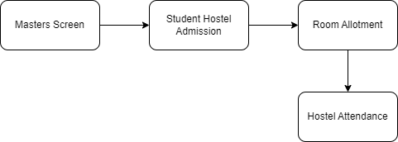

6.27.5 Use Case Diagram
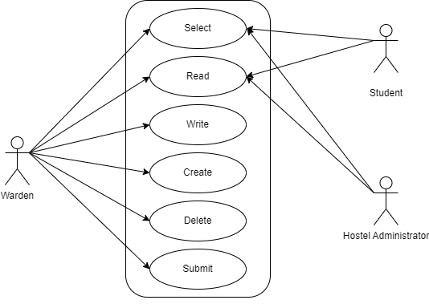
6.27.6 Table of Contents
Main Table Name:- TabHostel Attendance

6.27.7 Form Elaboration
Sl No. | Field Name | Type | Mandatory
1 | Student Hostel Attendance Information | Heading
2 | Room Allotment No. | Link
3 | Student Name | Data
4 | Roll No | Data
5 | Registration Number | Data
6 | Status | Select | 1
7 | Attendance Date | Date | 1
8 | Late Entry | Check
9 | Hostel | Data
10 | Room No | Data

6.27.8 Screen Authorization
Sl No. | Role | Level | Select | Read | Write | Create | Delete | Submit
1 | Hostel Administrator | 0 | 1 | 1 | 0 | 0 | 0 | 0
2 | Student | 0 | 1 | 1 | 0 | 0 | 0 | 0
3 | Warden | 0 | 1 | 1 | 1 | 1 | 1 | 1

6.27.9 Components And Modules
Module Related:- Education

6.27.10 Business Logic
- Go to Hostel Attendance list and click on New
- Select Room Allotment, Status
- Enter Attendance Date
- Check Late Entry
- Click on Save and Submit

6.27.11 Path of the screen
Home > Hostel > Attendance > Hostel Attendance

6.28 Hostel Attendance Tool

6.28.1 Overview
Hostel Attendance tool is the process of recording the presence or absence of students who reside in a hostel or dormitory. In this we take attendance in a bulk.

6.28.2 Description of Problem
Create a form to containing all Information about student attendance record.

6.28.3 Dependency
- Room Masters
- Hostel Masters

6.28.4 Flow Charts
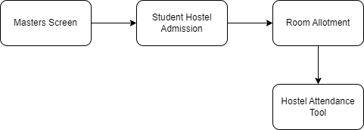

6.28.5 Use Case Diagram
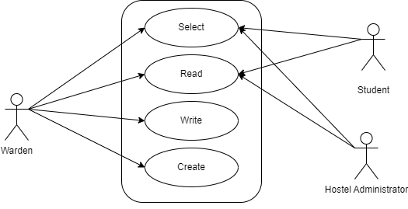

6.28.6 Table of Contents
Main Table Name:- TabHostel Attendance

6.28.7 Form Elaboration
Sl No. | Field Name | Type | Mandatory
1 | Date | Date | 1
2 | Hostel | Select | 1
3 | Room | Select | 1

6.28.8 Screen Authorization
Sl No. | Role | Level | Select | Read | Write | Create | Delete | Submit
1 | Hostel Administrator | 0 | 1 | 1 | 0 | 0 | 0 | 0
2 | Student | 0 | 1 | 1 | 0 | 0 | 0 | 0
3 | Warden | 0 | 1 | 1 | 1 | 1 | 0 | 0

6.28.9 Components And Modules
Module Related:- Education

6.28.10 Business Logic
- Go to Hostel Attendance Tool list and click on New
- Enter attendance day date
- Select Hostel and room
- Through that student will fetch accordingly
- Check student and mark as a present or absent

6.28.11 Path of the screen
Home > Hostel > Attendance > Hostel Attendance Tool

6.29 Hostel Clearance

6.29.1 Overview
Hostel Clearance is the process where student finished his time staying in hostel. In this due fees clearance occur. It may happen by Cancellation of Admission or Academic Pass-out.

6.29.2 Description of Problem
Create a form to containing all Information about student clearance.

6.29.3 Dependency
- Room Allotment

6.29.4 Flow Charts
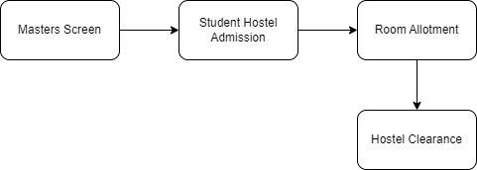

6.29.5 Use Case Diagram

6.29.6 Table of Contents
Main Table Name:- TabHostel Clearance

6.29.7 Form Elaboration
Sl No. | Field Name | Type | Mandatory
1 | Allotment Number | Link
2 | Student | Data
3 | Student Name | Data
4 | Roll No | Data
5 | Registration Number | Data
6 | Hostel | Data
7 | Room No. | Data
8 | Room Type | Data
9 | End Date | Date | 1
10 | Type of Clearance | Select | 1
11 | Due Status | Select | 1
12 | Due Amount | Currency
13 | Reason of Due | Data

6.29.8 Screen Authorization
Sl No. | Role | Level | Select | Read | Write | Create | Delete | Submit
1 | Hostel Administrator | 0 | 1 | 1 | 1 | 1 | 1 | 1
2 | Student | 0 | 1 | 1 | 0 | 0 | 0 | 0
3 | Warden | 0 | 1 | 1 | 0 | 0 | 0 | 0

6.29.9 Components And Modules
Module Related:- Education

6.29.10 Business Logic
- Go to Hostel Attendance Tool list and click on New
- Select Allotment Number through that all data fetch.
- Enter End Date
- Select Type of Clearance:- Cancellation of Admission or Pass-out
- Select Due Status: No Dues or Dues
- If You select Dues then two field fetch Due Amount and Reason of Due
- Enter Due Amount and Reason of Due
- Click on Save and Submit

6.29.11 Path of the screen
Home > Hostel > Hostel Clearance > Hostel Clearance

